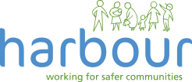

Do you know there’s support out there if you’re a victim of Domestic Abuse?

Ask for DANI

Domestic Abuse Support Needed Immediately

Do you feel controlled?

Have you ever felt scared or unsafe?

**STEP 2**

You will be offered an appointment to talk to our GP IDVA, or you will be given the details of a local domestic abuse helpline.

**STEP 1**

Approach a member of staff and

Ask for DANI, if you would like to speak to anIDVA.

(Independent Domestic Violence Advisor).

The IDVA can provide direct support to patients by contacting your GP Surgery for an appointment or call Mobile: 07917972042 Email: ainsley.cole@nhs.net

**Harbour Support Services** – 03000 202525 (24 hours a day)

Email: info@myharbour.org.uk