Help us to achieve NET ZERO Carbon Emissions
The Greenhouse Surgery recognises that the Sustainability Agenda has now become an integral part of healthcare operations focusing on social, environmental and economic development.
We recognise environmental sustainability as one of the great challenges of society and we will make a full contribution through engagement and practical action across all our activities.
Environmental sustainability and responsibility will be promoted as a core value and will be embedded in all our operational activities and investment/procurement decisions. Sustainable development will be seen as a process and not an event.

With around 4% of the country’s carbon emissions, and over 7% of the economy, the NHS has an essential role to play in meeting the net zero targets set under the Climate Change Act (Delivering a ‘Net Zero’ National Health Service). Primary care (eg GP Practices) is responsible for approximately 23% of NHS England’s emissions footprint. Medicines account for 25% of emissions within the NHS.
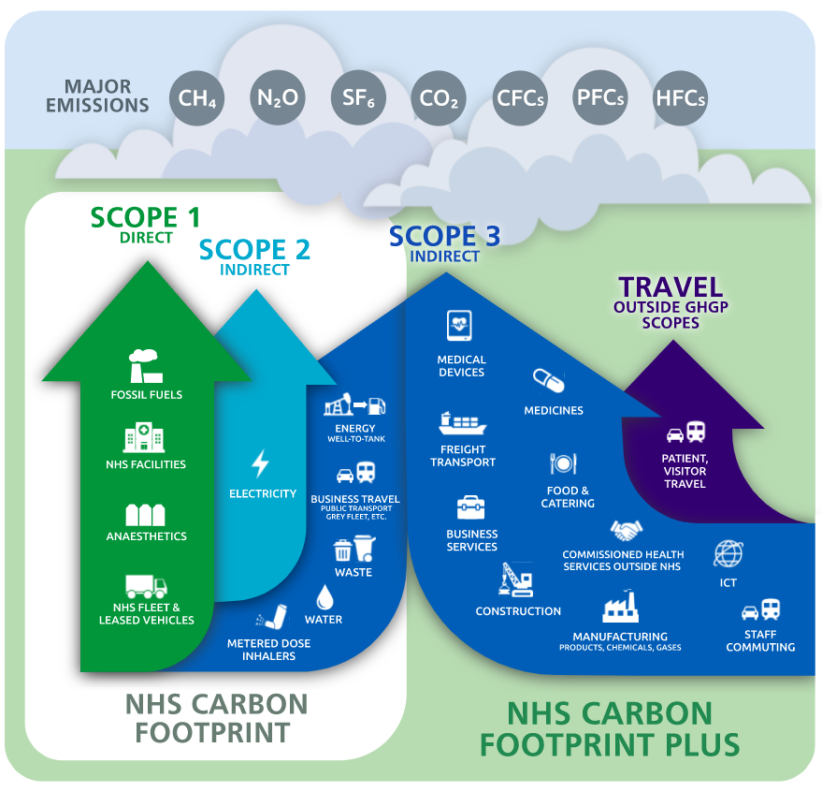

We can all help reduce the carbon footprint and it’s encouraging to understand that very often, simple changes can be highly effective:
- We could consider walking/cycling to our appointments/place of work or even use public transport
  - Saving one car journey a week of 16.7 miles (average daily commute) reduces the equivalent of 230kg of CO2e per person over a year.
- Using a refillable bottle for a year saves 64kg of CO2 compared with single use plastic bottles.
- Turning off lights/equipment/TV/computers etc (instead of leaving them on standby) and lights and controlling temperatures can lead to great savings
  - Use LED bulbs
- Using the right bin: In 2017, the NHS sent 15% of its waste to landfill, a total of 47,000 tonnes, a weight equal to 650 times the Space Shuttle.

If we all made small changes it would have a huge impact

